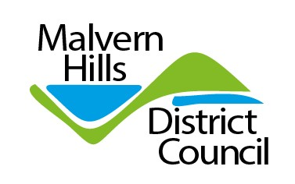
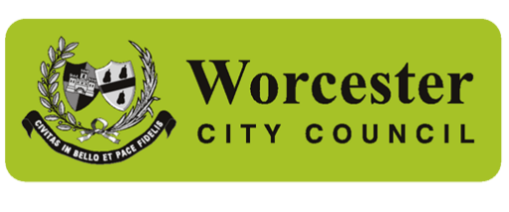


Dear residents,

So now we know. From April 2028, we will have a North Worcestershire Council and a South Worcestershire Council, delivering all services from bin collections to roads and social care for children and adults.

As leaders of the three district councils in South Worcestershire, we believe this is the right decision, not just for the communities we serve, but for the whole county. Moving to a unitary is a government decision. It has to happen and we are fully behind a South Worcestershire unitary.

Our task now is to make reorganisation a success. The people of Worcestershire will expect us to focus less on yesterday's arguments and more on tomorrow's opportunities. That is the responsibility we all now share.

There is a long and complex road ahead. Working with Worcestershire County Council and our colleagues in the north, we are determined to seize this once-in-a-generation opportunity to transform services, move towards long-term financial sustainability, and deliver better outcomes for residents.

The proposal for two councils emerged from extensive public consultation. You told us it was important to reflect the distinct character of north and south Worcestershire, keep decision-making close to communities and protect the local services people rely on. We’re pleased the Government listened to your voice, but you still have a key role to play.

The creation of unitary councils will enable the next stage of local government reorganisation and the devolution of power from Whitehall. This means that more decisions will be made locally by people who know Worcestershire well.

The subsequent formation in stage two of what are called strategic authorities, consisting of a number of new unitary councils constructively working together under a mayoral structure, allows the possibility of control of infrastructure development in our region supporting the economic growth and jobs that we need.

As the English White Paper says, “The number one mission of this government is to relight the fire of our economy and ignite growth in every region”. To that end, we stand ready to play our part in making local government reorganisation and English devolution a success.

Over the next nine months, your existing councils will help shape the new authorities. In May next year, you will elect the councillors who will lead the final preparations before the new councils take over on 1 April 2028.

For many councillors, this will be the final chapter of a lifetime of public service. For others, it will be the beginning of a new one. Whatever the future holds, it has been the greatest privilege to serve the people of Malvern Hills, Worcester and Wychavon. Until our final day, we will remain focused on serving our communities.

History will judge this moment not by the councils we create, but by the difference they make to people's lives. Our responsibility is to ensure the new councils inherit strong services, sound finances and thriving communities. That is the legacy we aim to leave. A new and strong economic voice.

Councillor John Gallagher
Leader of Malvern Hills District Council

Councillor Lynn Denham
Leader of Worcester City Council

Councillor Richard Morris
Leader of Wychavon District Council

