Proposed changes to HPC Standing Orders, to reflect and align the new FOI Policy.
Current
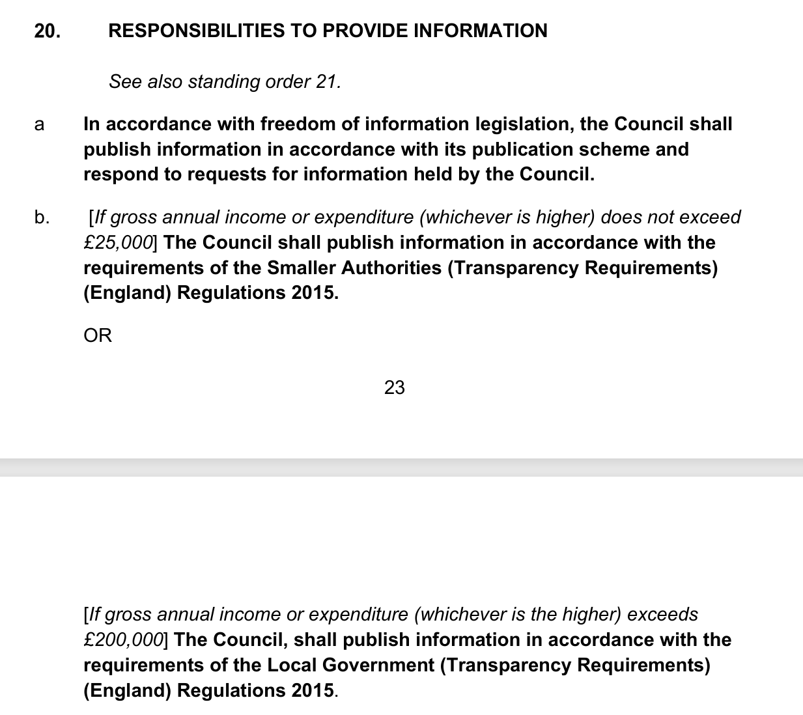
Proposed Changes
- The Council shall comply with the requirements of freedom of information and transparency legislation in accordance with its adopted Freedom of Information Policy.

- [If gross annual income or expenditure (whichever is higher) does not exceed £25,000] The Council shall publish information in accordance with the requirements of the Smaller Authorities (Transparency Requirements) (England) Regulations 2015.
OR
[If gross annual income or expenditure (whichever is the higher) exceeds £200,000] The Council, shall publish information in accordance with the requirements of the Local Government (Transparency Requirements) (England) Regulations 2015.

